[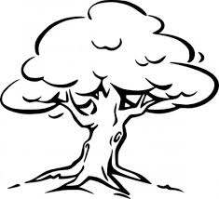](http://www.google.com.au/url?sa=i&rct=j&q=&esrc=s&source=images&cd=&cad=rja&uact=8&docid=Q-jachXC6K5l9M&tbnid=dEZcnnM6t4ztbM:&ved=0CAUQjRw&url=http://all-free-download.com/free-vector/vector-clip-art/tree_outline_clip_art_11785.html&ei=gkD1U_q5CIzp8AXO4oLQAQ&bvm=bv.73231344,d.dGc&psig=AFQjCNFOn96papxJpTkYcyqtzYCWu8mjvQ&ust=1408668120729314)Investigating and Earth Science Year 8

Mid Topic Test

Name: _______________________________________ Total: 68 marks

Part A: Multiple-Choice (10 marks)

1. Which of the following lists the layers of the Earth, from inside to outside, in the correct order?

**A** Inner core, Mantle, Outer core, Crust.

**B** Crust, Mantle, Outer core, Inner core.

**C** Inner core, Outer core, Mantle, Crust.

**D** Outer core, Inner core, Mantle, Crust.

2. Which of the following lists contains only measuring equipment?

**A** a beaker, a graduated cylinder, a conical flask and an electronic scale.

**B** a measuring cylinder, a test-tube, a conical flask and a spatula.

**C** a beaker, a graduated cylinder, a test-tube and a filter funnel.

**D** a measuring cylinder, a evaporating basin, a beaker and a conical flask.

3.Which of the following is **not** a safety rule in a Science laboratory?

**A** do not run or push.

**B** always wear safety glasses when using chemicals.

**C** do not eat, taste, drink or sniff anything unless told to by a teacher.

**D** if you break something immediately get rid of it.

4. The hot molten rock that pours out of a volcano is known as:

**A** lava.

**B** sediment.

**C** magma.

**D** igneous rock.

5. Which of the following are all true about **extrusive igneous rocks**?

**A** coarse-grained, light coloured, small crystals, example - basalt.

**B** fine-grained, light coloured, small crystals, example - granite.

**C** coarse-grained, dark coloured, large crystals, example - granite.

**D** fine-grained, can have spaces(air bubbles) or appear glassy, small crystals, example – basalt.

6. Which of the following are all forms of weathering?

**A** wind, ice freezing, magma cooling, acid rain.

**B** temperature change, living plants, wind blowing sand hills away.

**C** wind, ice freezing, temperature change, acid rain, living plants.

**D** crystallisation of salts, living plants, a river carrying sediments away.

7. Sedimentation can occur in which place/s

**A** when a river breaks its banks and floods.

**B** where a river enters a lake.

**C** bends of rivers.

**D** all of the above.

8. Which of the following is an inference?

**A** everyone is packing up.

**B** it must be nearly home time.

**C** the bell will go soon.

**D** the time is 3.01pm.

9. Which of the abbreviations for the units are all correct?

**A** gram – g, litre – L, kilogram – kg, millimetre – mm, minutes – min.

**B** gram – gm, litre – L, kilogram – kg, millimetre – mm, minutes – min.

**C** gram – g, litre – l, kilogram – kg, millimetre – ml, minutes – min.

**D** gram – g, litre – L, kilogram – kgm, millimetre – mm, minutes – mins.

10. Which graph would you use for a set of continuous data, such as time and temperature?

**A** column or bar.

**B** pie.

**C** line.

**D** none of the above.

**Part 2: Short Answer** (58 marks)

1. **Match** the following terms with their correct meaning. Note: not all words will be used.

Weathering, erosion, graduated cylinder, beaker, test-tube, lithosphere, mantle, igneous rock, sedimentary rock, intrusive, extrusive, lava, magma, crystals, minerals, granite, basalt, pumice, sedimentation, independent variable, dependent variable, controlled variable, bench mat, Bunsen burner, tripod.

a) Molten rock above ground __________________________________________________

b) Found interlocking in igneous rocks ___________________________________________

c) The breaking down of rocks into smaller pieces __________________________________

d) An extrusive igneous rock formed from exploding lava ____________________________

e) A small glass tube used to mix chemicals _______________________________________

f) The outer most layer of the Earth _____________________________________________

g) Means formed under the Earth’s surface ________________________________________

h) The variable we measure in an experiment______________________________________

i) Has three legs and stands over a Bunsen burner __________________________________

j) Found in rocks ____________________________________________________________

(10 marks)

2. **Draw** and **label** a diagram of the Earth’s layers:

(5 marks)

3. a) **Describe** how intrusive and extrusive rocks are different:

___________________________________________________________________________

___________________________________________________________________________

___________________________________________________________________________

___________________________________________________________________________

(2 marks)

b) **Explain** why intrusive and extrusive rocks are different:

___________________________________________________________________________

___________________________________________________________________________

___________________________________________________________________________

(2 marks)

4. a) **List** three igneous rocks __________________________________________________

1. **List** two characteristics of an igneous rock ___________________________________

_______________________________________________________________________

_______________________________________________________________________

1. **List** two ways an igneous rock could be formed ________________________________

_______________________________________________________________________

_______________________________________________________________________

(3 marks)

5. **Justify** the following statement: *It is safer to turn the gas on* ***last*** *when lighting a Bunsen than to light the match* ***last****.*

___________________________________________________________________________

___________________________________________________________________________

___________________________________________________________________________

(2 marks)

6. **Explain** how weathering is different to erosion: ____________________________________

___________________________________________________________________________

___________________________________________________________________________

(2 marks)

7. **Classify** the following types of weathering as physical or chemical:

1. temperature ___________________________________________________
2. acids ________________________________________________________
3. living plants __________________________________________________
4. water freezing _________________________________________________

(4 marks)

8. **Identify** the process as either **weathering** or **erosion** in the following situations:

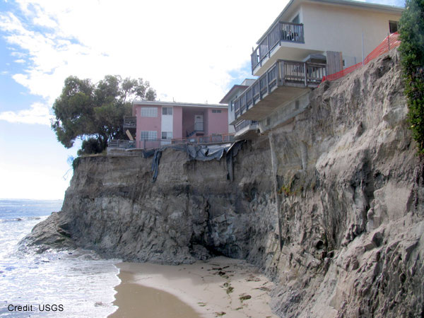

a)

____________________________

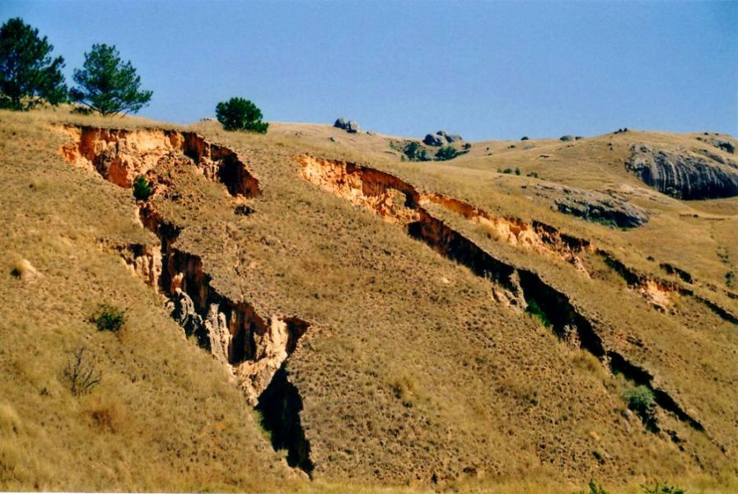

b)

____________________________

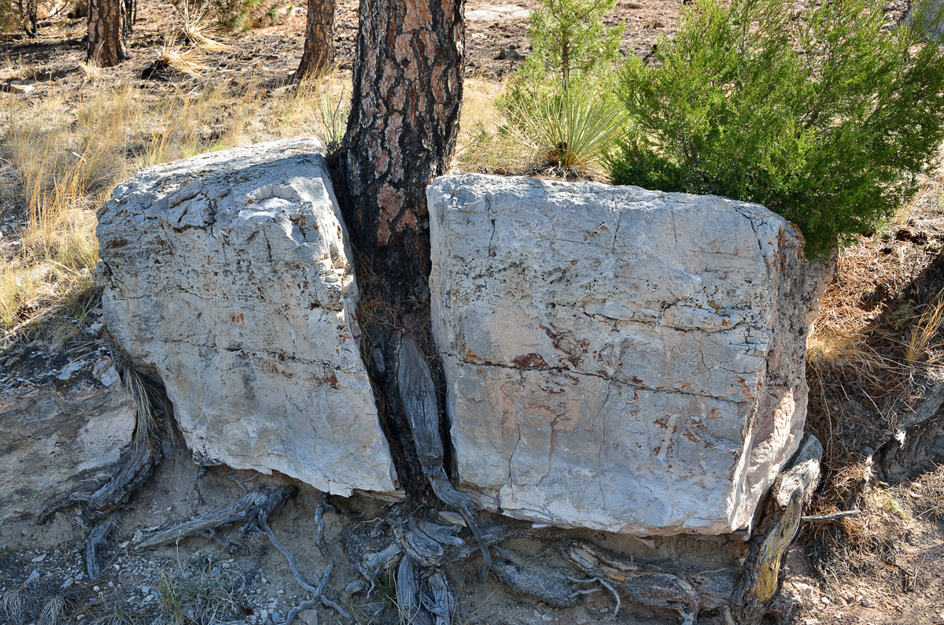

c)

____________________________

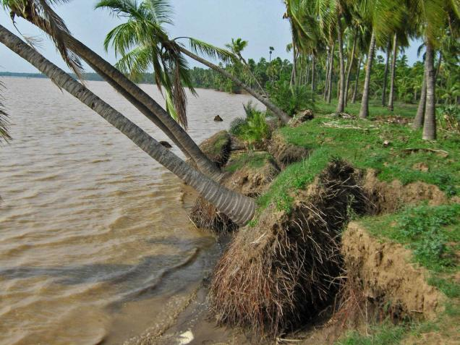

d)

__________________________

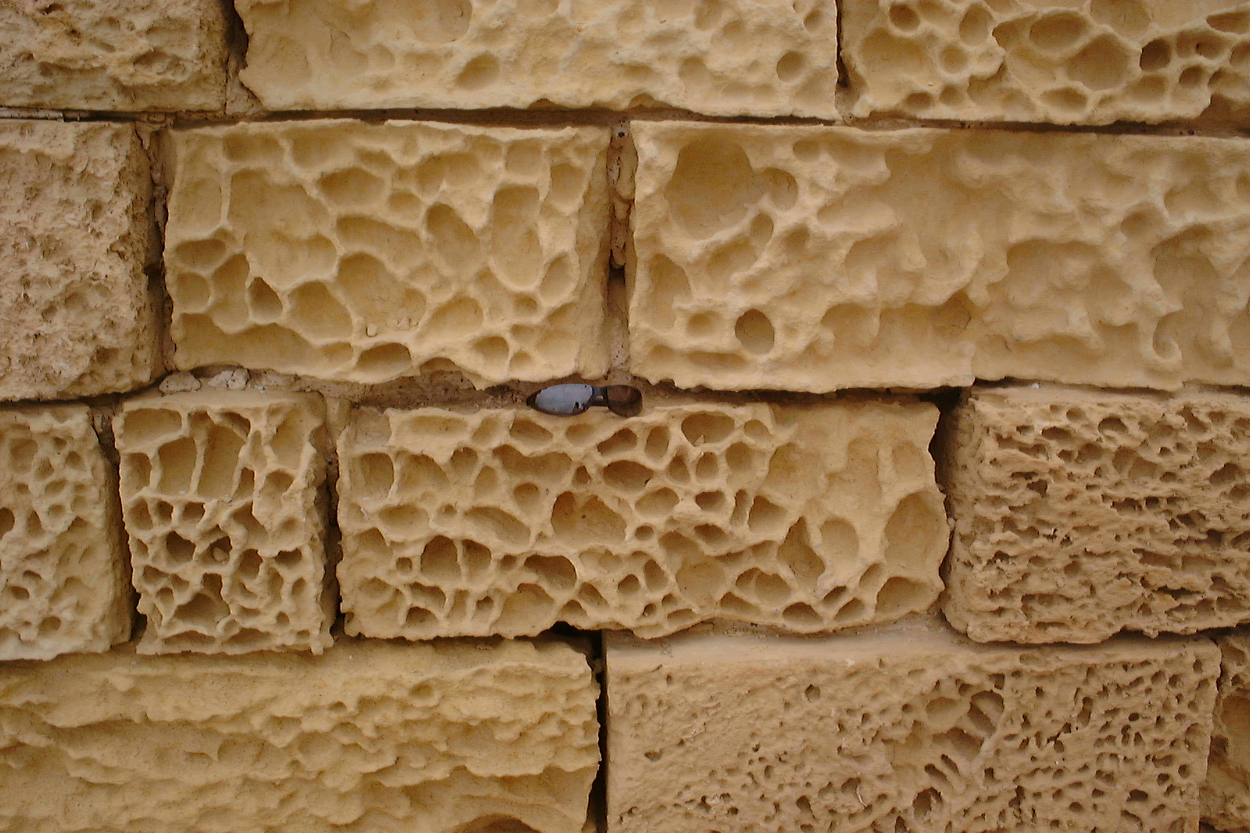

e)

_______________________

(5 marks)

9. A fast flowing river can carry very large sediments through the water. A slow moving river can only carry small particles.

The following table shows the largest particle size at different positions along a river, starting from the river mouth (where the river meets the ocean) moving inland.

|  |  |
| --- | --- |
| **Distance (km)** | **Largest particle size (g)** |
| 0 | 1 |
| 0.5 | 1 |
| 1.0 | 2 |
| 1.5 | 5 |
| 2.0 | 24 |
| 2.5 | 67 |
| 3.0 | 156 |
| 3.5 | 184 |
| 4.0 | 244 |
| 4.5 | 487 |
| 5.0 | 535 |

a) Graph the results above as a line graph. (5 marks)

b) Where are the largest particle carried by the water? ___________________________

_____________________________________________________________________

(1 mark)

c) **Estimate** how far up river would you be if the particle size were 330g? ___________

­­­­­­­­­_____________________________________________________________________

(1 mark)

d) **Compare** the particle size at 1km to 3km ___________________________________

_____________________________________________________________________

_____________________________________________________________________

(2 marks)

e) **Estimate** the particle size at 3.75km ______________________________________

(1 mark)

f) **Explain** why the above estimate may not necessarily be accurate ________________

____________________________________________________________________

_____________________________________________________________________

_____________________________________________________________________

_____________________________________________________________________

(2 mark)

10. **Define** the following:

i) Magma _____________________________________________________________

___________________________________________________________________________

ii) Independent variable ___________________________________________________

___________________________________________________________________________

iii) Erosion _____________________________________________________________

___________________________________________________________________________

iv) Lithosphere __________________________________________________________

___________________________________________________________________________

(4 marks)

12. **State** the amount in each graduated cylinder (the first one is done for you)

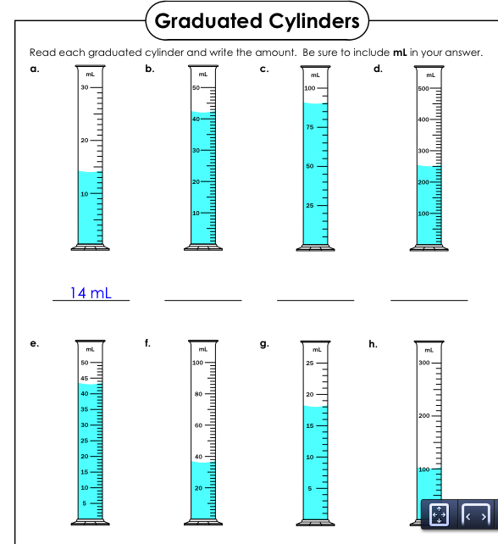

(7 marks)